Mechanism of size effects in microcylindrical compression of pure copper considering grain orientation distribution

Chuan-Jie Wang, Chun-Ju Wang*(iD XXXX-XXXX-XXXX-XXXX),
Bin Guo, De-Bin Shan, Yan-Yan Chang

Received:*** / Revised: *** / Accepted: ***
© The Nonferrous Metals Society of China and Springer-Verlag Berlin Heidelberg 2013

Abstract In microscale deformation, the magnitudes of specimen and grain sizes are usually identical, and size- dependent phenomena of deformation behavior occur, namely, size effects. In this study, size effects in micro- cylindrical compression were investigated experimentally. It was found that, with the increase of grain size and decrease of specimen size, flow stress decreases and inhomogeneous material flow increases. These size effects tend to be more distinct with miniaturization. Thereafter, a modified model considering orientation distribution of surface grains and continuity between surface grains and inner grains is developed to model size effects in micro- forming. Through finite element simulation, the effects of specimen size, grain size, and orientation of surface grains on the flow stress and inhomogeneous deformation were analyzed. There is a good agreement between experimental and simulation results.

Keywords Microforming; Cylindrical compression; Size effects; Grain orientation; Inhomogeneous deformation

C.-J. Wang, C.-J. Wang*, B. Guo, D.-B. Shan, Y.-Y. Chang School of Materials Science and Engineering, Harbin Institute of Technology, Harbin 150001, China
e-mail: cjwang1978@hit.edu.cn

C.-J. Wang, B. Guo, D.-B. Shan
Key Laboratory of Micro-Systems and Micro-Structures Manufacturing, Harbin Institute of Technology, Harbin 150080, China

1 Introduction

With a rapid development of microelectromechanical sys- tems, the demand for microparts, such as microscrews,micropins, microcups, microgears, and micro-lead frames, has been increasing. Micromanufacturing methods, such as lithographie, galanoformung, abformung (LIGA) , quasi- LIGA, etching, micro- electrical discharge machining (EDM), laser technology, microelectrochemical machining, and micromechanical cutting, are unable to satisfy the requirements for products with low price, high efficiency, and large production volumes.
Microforming is a manufacturing process that can form microparts with dimensions or structures at least in two-dimensional scale in the sub- millimeter range [1–3]. ………….

2 Experimental

Cylindrical specimens of pure copper were machined to Φ0.81 mm × 1.62 mm, Φ1.01 mm × 1.62 mm, Φ1.54 mm × 1.62 mm, and Φ 2.8 mm × 4.2 mm.
The speci- mens were annealed under conditions of 430 °C for 1 h, 700 °C for 8 h, and 700 °C for 24 h to modify the grain size L (10, 45, and 65 μm)……………………

3 Results and discussion

3.1 Theoretic analysis

3.1.1 Theoretic model

With miniaturization, fraction of free surfaces increases, which has dominated influence on the total mechanical properties of material.
The effect of free surfaces on the…………

4 Conclusion

In this study, microcylindrical compression of pure copper with different grain and specimen sizes was carried out. Experimental results show that, with the increase of grain size and decrease of specimen size, decrease of the flow stress and increase of non-uniform plastic deformation occur……..

Acknowledgments This study was financially supported by the National Natural Science Foundation of China (Nos. 50835002 and
51105102).

References

[1] Geiger M, Kleiner M, Eckstein R. Microforming. Ann CIRP.
2001;50(2):445.
[2] Engel U, Eckstein R. Microforming-from basic research to its realization. J Mater Process Tech. 2002;125–126(9):35.
[3] Xu Q, and Liu FS. Transformation behavior and shape memory effect of Ti_{50−x}Ni₄₈Fe₂Nb_{x} alloys by aging treatment. Rare Met. 2012;31(4):311

Tables
Table1 Measured values of density, specific heat, thermal diffusivity, CTE of Ti-coated graphite fiber/Cu composites, uncoated graphite fiber (50 vol%)/Cu composite, and sintered copper

Fiber content  /vol% | Theoretical density /(g·cm⁻³) | Measured density /(g·cm⁻³) | Relative density /% | Specific heat  /(J·g⁻¹) | Thermal diffusivity  /(mm2·s⁻¹) (X–Y//Z)
0 (Sintered Cu) | 8.96 | 8.93 | 99.67 | 0.385 | 94.24
35 | 6.51 | 6.47 | 99.39 | 0.425 | 139.29//85.83
40 | 6.17 | 6.11 | 99.03 | 0.436 | 147.90//83.95
45 | 5.83 | 5.75 | 98.63 | 0.443 | 157.82//78.64
50 | 5.48 | 5.38 | 98.17 | 0.455 | 166.26//67.59
50 (Uncoated) | 5.59 | 5.44 | 97.32 | 0.451 | 72.55//42.56

Figures
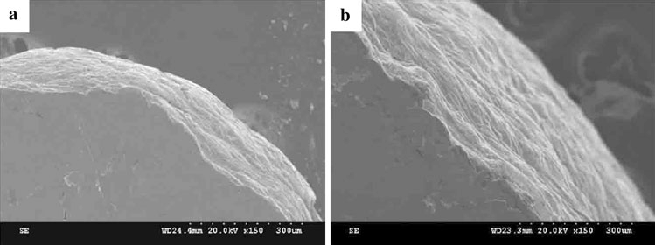

Fig.1 Surface topographies (SEM image) of deformed specimens with different sizes: a Φ0.81 mm × 1.62 mm and b Φ2.8 mm × 4.2 mm

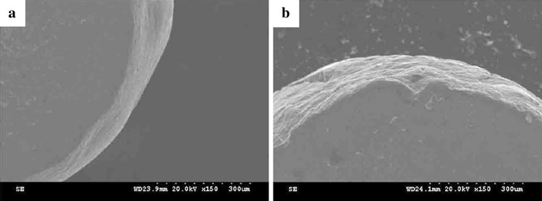

Fig.2 Surface topographies (SEM image) of deformed specimens with different grain sizes: a L = 10 μm and b L = 65 μm

